**Logo%20Main%20200**

**Boston University**

**Electrical & Computer Engineering**

**EC463 Capstone Senior Design Project**

**Problem Definition and Requirements Review**

DSeye

Submitted to:



Darren Roblyer and Raaef Istfan

44 Cummington Mall

Boston, MA 02215

(617) 358-1554

[roblyer@bu.edu](mailto:roblyer@bu.edu), [raeef@bu.edu](mailto:raeef@bu.edu)

by

Team # 3

DOS Amigos

Team Members

Michael Ethier [methier@bu.edu](mailto:methier@bu.edu)

Solomon Utain [sutain@bu.edu](mailto:sutain@bu.edu)

Ami Vyas [amivyas@bu.edu](mailto:amivyas@bu.edu)

Alexander Wang [amwang@bu.edu](mailto:amwang@bu.edu)

Submitted: Monday, October 10, 2016

**Customer Sign-Off: ____________________ ___________________**

#### DOSeye

#### Table of Contents

Project Summary 2

1 Need for this Project 3

2 Problem Statement and Deliverables 4

3 Visualization 5

4 Competing Technologies 6

5 Engineering Requirements 7

6 Appendix A References. 8

# Project Summary

This project aims to consolidate the current Diffuse Optical Spectroscopic Imaging monitor into a smaller, wearable device which can continuously take measurements of a tumor during a chemotherapy treatment. This would help doctors collect a larger sample of data to judge the success of the treatment, and also be convenient for the wearer of the device. The monitor will use a Vertical Cavity Surface Emitting Laser as a light source, and an avalanche photodiode as a detector. The signal will be sent through a trans-impedance amplifier and analyzed in an attached unit to determine the status of the tumor.

# Need for this Project

# Breast cancer is one of the most common forms of cancer in women, at about 12.5% of women having some form of it in their lifetime. Chemotherapy is often administered to shrink the tumor prior to surgery; however, a patient response to the treatment is not always guaranteed. The harsh side effects of chemotherapy include pain, fatigue, nausea, hair loss, and even negative response where the tumor size increases instead of decreasing. This shows a need to detect the response of a tumor as quickly as possible to determine if chemotherapy should be continued or if it is doing more harm than good.

# One current technology to quickly monitor the state of a tumor during chemotherapy is Diffuse Optical Spectroscopic Imaging (DOSI). This requires a light source which modulates the intensity of light at a certain frequency and directs it into tissue which contains a tumor. A detector which can measure the phase shift and change in intensity of the light is placed at a point a certain distance away from the light source and the signals are amplified and analyzed. The current sensor used for DOSI technology is big, bulky, and needs to be operated by a nurse, practitioner, or doctor. Measurements are time-consuming, taking around 30 minutes to an hour. This project aims to make this sensor into a small, comfortable, wearable device which can take constant measurements throughout the chemotherapy session without the assistance of a medical professional. This will save time and increase the amount of data taken during the session.

# Problem Statement and Deliverables

The current DOSI probe used in clinics is a large device that must be operated by a technician at discrete intervals throughout a multiple hour chemotherapy session. This probe offers multiple issues:

* Large size of probe
* Requires technician to operate
* Unable to take continuous measurements throughout treatment

Our goal is to design and construct a DOSI probe for cancer treatment meant to improve upon the current DOSI probe. Similar to the current device, our design will employ principles of spectroscopy to measure hemodynamics within breast tissue during chemotherapy. The functional core of the device will be an optode. However, the device will be much smaller than the current probe, largely due to its inclusion of miniaturized components in its design. Lending to its small size, it will be made to be comfortably worn directly on skin for hours at a time. This eliminates the need to be operated by a technician. Because the probe will be mounted on skin, it will be able to continuously take measurements rather than only take periodic measurements during treatment. Ultimately, the probe will have the functionality of the current probe, but without the need for human operation, and with significantly more data to analyze.

In order to design and construct a probe that meets what we hope to achieve, our probe must meet specific deliverables. Our probe will consist of a single optode or a multi-optode array on a rigid PCB. Each optode will consist of a vertical-cavity surface-emitting laser (VCSEL) as a source and a miniature advanced performance detector as a receiver. Optodes must be capable of taking frequency domain measurements. The probe’s circuitry must operate in the 50 MHz to 1 GHz frequency range, i.e. radio frequency. The multi-optode system must be equipped to switch between optodes. Additionally, the probe must be designed to be worn comfortably for hours at a time. This probe is connected to a network analyzer which takes in all of the data. There will be a software component related to this project which entails a user interface which shows the data collected from the tumor. This will either be a more user-friendly version of the current prototype Labview program or it will be an entirely new user interface. There will also be some sort of cloud storage server that will be secured for the use of storing patients’ data.

# Visualizations

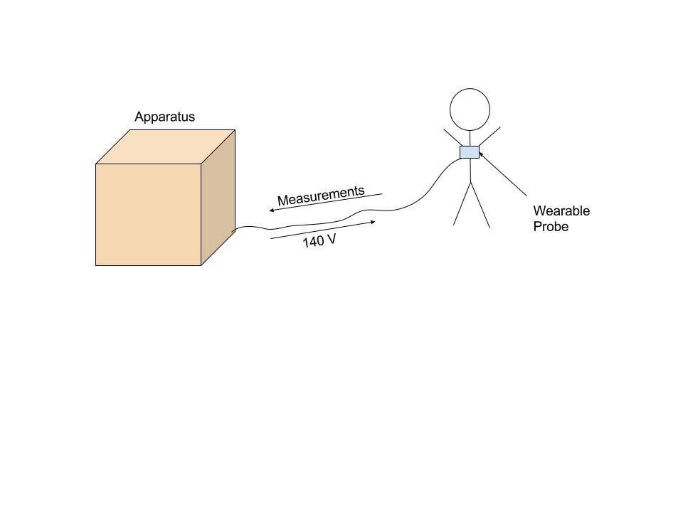

Signal Analysis Software

*Figure 1.1 This is the overall visualization for how the device would work. The probe would be worn by the patient for a few hours and take measurements, while being connected and powered by the remaining apparatus and simultaneously sending the measurements to the apparatus for analysis. The apparatus will have a signal analysis software with a user interface for the doctor to view the data.*

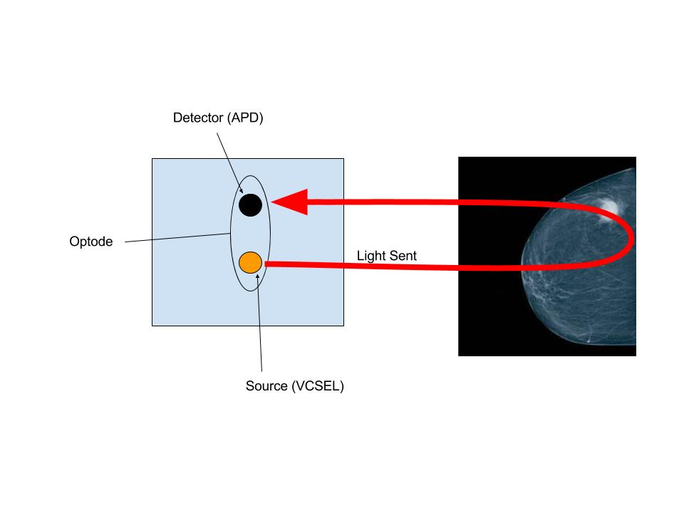

*Figure 1.2 The left diagram shows a single optode which will be the main functioning part of the product. The light from the source travels into the breast tissue and back out to be measured by the detector. The optode will be part of the probe which will be placed directly on the breast of the patient.*

# Competing Technologies

Two major competing technologies are the current Diffuse Optical Spectroscopy probe and Magnetic Resonance Imaging, otherwise known as MRI. The current DOS probe is operated manually by a nurse during chemotherapy sessions. The operator moves the probe point to point and this takes about thirty minutes to an hour for each breast. This is the most directly competing technology as it does the exact same thing which is to use DOS to detect how the tumor is responding to chemotherapy. The role of this probe is also to use a light source and a detector to pick up information about the absorption and the scattering properties of the tissue that cannot be determined by other methods. MRI is another competing technology which is used to find information about how the tumor is reacting to chemotherapy. MRI functions in a different way though, as it uses magnetic fields to create an image of the breast. For MRI, early imaging markers take up to a couple of months to see how the tumor is reacting.

Other forms of competing technologies are Computed Tomography scans and blood marker tests. Both of these are used to figure out if the chemotherapy is working. CT scans check how the tumor is responding by using x-rays to create a three dimensional-picture of the inside of the breast and these pictures are used to see if the tumor is shrinking with the treatment. This like MRI takes longer to see how the tumor is responding to the treatment. Blood marker tests are done because they look for a specific protein in the blood which is produced by the cancer and they detect circulating cancer cells that have broken off from the tumor and moved into the bloodstream. These are both markers for testing how the cancer is responding.

# Engineering Requirements

**Functions**

The probe must be able to emit visible and near-infrared light at wavelengths of 660 nm, 680 nm, 775 nm, and 795 nm. The probe must also be able to detect these wavelengths and measure the intensity of light that scatters through the tissue and makes it back to the detector. The probe must also be able to provide up to and under 160 volts at low power to the VCSELs without the circuit or any of the elements breaking down. The probe must be able to be worn by the patient for approximately three hours comfortably and safely. The probe will communicate the measurements taken back to the rest of the machinery for analysis.

**Objectives**

For a single optode, there must be a 5% drift or lower for a two-hour testing period for the optical properties of μs and μa when testing against an optical phantom. This represents the goal for the device’s precision. For accuracy of a single optode, there must be an error margin of 10% or less when testing results with optical phantoms are compared to current “gold standard” of the benchtop system. The Signal to Noise Ratio or SNR requirement is that the SNR must be at least 10.

**Constraints**

The detector for the optode must implement a small 5.5 mm chip provided by Hamamatsu containing a 0.2 mm avalanche photodiode (APD) and transimpedance amplifier (TIA). The APD has a breakdown voltage of 160 volts, requires about 140 volts DC to operate, and has a cutoff frequency of 120 MHz. The source for the optode must implement a vertical-cavity surface-emitting laser (VCSEL) that can emit four different wavelengths of light in the visible and near-infrared (NIR) spectra. The RF circuit that the probe will use to communicate with the rest of the machinery will operate between 50 MHz and 1 GHz. Since a VCSEL is being used, the American National Standards Institute (ANSI) laser standards must be met.

# Appendix A: References

"Breast Cancer - Diagnosis | Cancer.Net." Cancer.Net. 2016. Accessed October 10, 2016. <http://www.cancer.net/cancer-types/breast-cancer/diagnosis>.

"Breast Cancer Tests: Screening, Diagnosis, & Monitoring | Breastcancer.org." Breastcancer.org. Accessed October 10, 2016. <http://www.breastcancer.org/symptoms/testing/types>.

Cancer, Cleveland Clinic. "How Can We Tell If Chemotherapy Is Working?" - What Is Chemotherapy? Accessed October 10, 2016. <http://chemocare.com/chemotherapy/what-is-chemotherapy/how-to-tell-if-chemotherapy-is-working.aspx>.

UC Davis Health System, Department of Public Affairs and Marketing. "UC Davis Research Shows Why Tumor Cells Resist Popular Breast Cancer Drug." UC Davis Health System Feature Story: Research Shows Why Tumor Cells... Accessed October 10, 2016. <http://www.ucdmc.ucdavis.edu/welcome/features/20080709_cancer_sweeney/>.

"U.S. Breast Cancer Statistics | Breastcancer.org." Breastcancer.org. Accessed October 10, 2016. <http://www.breastcancer.org/symptoms/understand_bc/statistics>.